 

PROPOSAL FOR:

EEF

Lesson Planning Platform

# ABOUT division5

We are a creative company specialized in building digital products that solve real-world business problems. We produce work that we are proud of, for people and organizations that we believe in.

Since 2015 we design, build, and ship amazing products and services. So far, we have delivered 50+ projects for startups, SMEs, and enterprises across various industries and located in Europe and the US.

We have a talented and specialized in-house team of 20+ people, skilled in a range of disciplines focused on our Clients needs and objectives. We take extra care around the way people experience and engage with our products and services.

Our core services include: Extended Team Services, Web Design & Development, Mobile Development as well as Product Development.

# REFERENCES

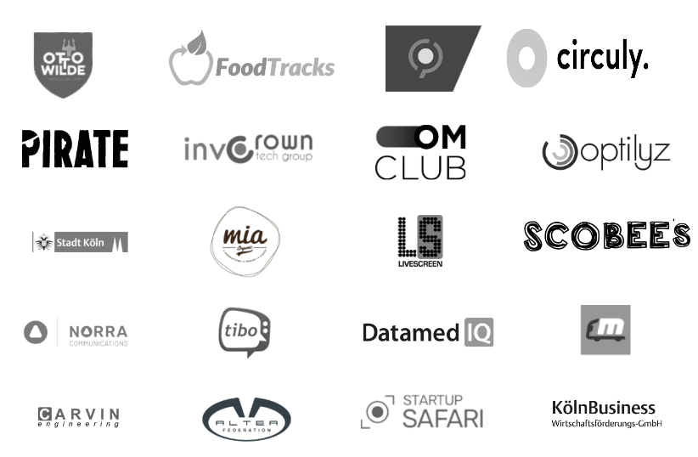

Also see [our portfolio](http://portfolio.division5.co) for further references.

# 

# TABLE OF CONTENTS

ABOUT division5 2

REFERENCES 2

TABLE OF CONTENTS 3

FUNCTIONAL DESCRIPTION 4

TECHNICAL PROPOSAL 4

TECHNOLOGY STACK 5

PROJECT REFERENCES 5

HOSTING AND CODE REPOSITORY 5

PROJECT QUOTE AND TIMELINE 5

PAYMENT TERMS 5

CONFIDENTIALITY 6

INTELLECTUAL PROPERTY RIGHTS 6

# 

# FUNCTIONAL DESCRIPTION

This proposal is composed for the requested services by EEF for the development of a web-based platform which will help teachers reduce the time needed to prepare a lesson plan by several folds, through different steps that will search and suggest lesson materials for specific topics.

The platform aims to facilitate the process of preparing a lesson by including information, graphics, multimedia, quizzes and third party websites, both theoretical and practical experiences retrieved from searching on the web.

This proposed project aims to build a platform that is scalable and where users can register, plan lessons, save them for reuse in the future, and present them to classes. The online platform allows functions like: viewing/downloading/uploading data necessary for the lesson, showing multimedia materials when needed, introducing materials for a specific step and choosing different types of lesson modes for different topics to be introduced in the lesson plan.

The platform will be designed to have two types of view modes; the teacher’s view mode which will display all the steps that compose the lesson plan and the students mode which displays each step at a time for the students in the time the teacher decides to.

The platform gives the participants the opportunity to transit from one step to another. It is designed to have an intuitive user interface where the user does not need much training on how to use it. It takes into account all of the users’ needs and creates an interface that reinforces consistency and helps users accomplish their tasks in the most seamless way possible.

# TECHNICAL PROPOSAL

Division5 manages projects in an Agile methodology by using scrum, through milestones and two-week sprints. The project will be developed and delivered in phases that could potentially be engaging different team members at the same time. The project manager will be in continues contact with the contracting party to inform on the progress and receive feedback whenever its deemed necessary.

The platform, is proposed to be developed in React JS for several reasons. Among the technologies available, React JS is easy to interact with and it is easy to create reusable web components. For the development process but also the maintenance it has a better workflow. Division5 has high expertize in the mentioned technology and there are many project references which could be showcased. As for the back-end, Node JS is proposed to be used for the development. This type of technology is suitable for platforms that are intended to be scalable and also allows the development to easily implement REST APIs.

Project implementation will starting from the development of the infrastructure of the platform to the features and milestones. These are identified, shaped and grouped to minimize the time of development and maximize the effectiveness of the team work. More information about the work plan, milestones and the estimated time of development can be found on **ANNEX 1**, attached to this proposal.

What needs to be taken in consideration is the extra fees that come with the implementation of the content search. Since we intend to use google services the platform charges extra fees if we exceed a certain amount of search per day. More specifically, google allows 100 queries/day for free, but is this is exceeded they charge 5$ per 1000 search queries. More information on the pricing can be found [HERE](https://developers.google.com/custom-search/v1/overview).

During the lifetime of the project, division5 offers full costumer support and technical assistance for the entire development process of the platform. In addition, within the services provided by the company, there is also platform maintenance which could be a contractual agreement after the completion of the project. Division5 offers one month warranty after the projects is concluded as a customer support for any bug fixing that might be needed. We guarantee to use our best efforts to fulfill and exceed the contracting party expectations on the deliverables identified.

# TECHNOLOGY STACK

React JS, Node JS

# PROJECT REFERENCES

Division5 is a design & development agency working with companies and organisations to build web, mobile, and connected devices that solve real-world business problems. We produce work that we are proud of, for people and organizations that we believe in. Design thinking and agile methodologies enable us to deliver better products faster. Through our human-centered approach, we help companies build long-lasting innovative solutions that provide value. We work with startups, SMEs, enterprise companies, and institutions across various industries. Here are some of our previous projects that showcase our work and capability to develop similar projects to the one proposed:



**SCHOOL MANAGEMENT SYSTEM**

Scoobees is a school management system where schools, teachers, extracurricular educational organizations and learning locations can easily design their learning materials digitally individually and also use other approved materials in the platform.

Excellent planning is almost always the key for a productive developing process. We managed to do a clear division of the tasks and made sure to be on a constant communication and worked closely with the client by being flexible and managing expectations. This way we implemented the features quickly and reached the common goals.

Link: <https://scobees.com/>

Also see [our portfolio](http://portfolio.division5.co) for further references.

# HOSTING AND CODE REPOSITORY

The platform will be hosted during the testing and development period at the division5 servers. After the project completion, the development will be fully transferred to EEF servers.

# 

# CONFIDENTIALITY

Division5 represents that the execution and development of this project does not conflict with or breach any contractual or other obligations to which we are committed to. We acknowledge its responsibility, both during and after the term of the appointment, to use all reasonable efforts to preserve the confidentiality of any proprietary or confidential information or data developed by division5 on behalf of the EEF or disclosed by EEF to division5.

# 

# INTELLECTUAL PROPERTY RIGHTS

Any rights in data or copyrights in works of authorship, including software, firmware or other forms of computer programs, created by one or more employees of division5 during the lifetime of the project, shall be transferred property to the contracting party. EEF will own the intellectual property that will be developed during the development period.

**AGREEMENT ENTERING PARTIES**

MARK SYLA

ENGJELL RRAKLLI

______________________________

Name Surname

______________________________

Signature

______________________________

Name Surname

______________________________

Signature

EGLANTINA CUMRAKU

______________________________

Name Surname

______________________________

Signature

**ANNEX 1**

|  |  |  |  |  |  |  |  |  |  |  |
| --- | --- | --- | --- | --- | --- | --- | --- | --- | --- | --- |
| |  | | --- | |  | | | |  |  |  |  |  |  |  |  |
| **Month 1** | | | | **Month 1** | | | |
| W1 | W2 | W3 | W4 | W1 | W2 | W3 | W4 |
| 0 | **Infrastructure** |  | | | |  | | | |
| 0.1 | Frontend Setup |  |  |  |  |  |  |  |  |
| 0.2 | Backend Setup |  |  |  |  |  |  |  |  |
|  | **Features/Milestones** |  | | | |  | | | |
| 1 | Registration and Authentication |  | | | |  | | | |
| 1.1 | Initial Registration Form |  |  |  |  |  |  |  |  |
| 1.2 | Log in Form |  |  |  |  |  |  |  |  |
| 1.3 | Authorization/Authentication Functionality |  |  |  |  |  |  |  |  |
| 2 | Lesson Plan Module |  | | | |  | | | |
| 2.1 | Search implementation |  |  |  |  |  |  |  |  |
| 2.2 | Design Adoption |  |  |  |  |  |  |  |  |
| 2.3 | Lesson Feature integration |  |  |  |  |  |  |  |  |
| 2.4 | Step Feature integration |  |  |  |  |  |  |  |  |
| 2.5 | Text Data handling (upload/download) |  |  |  |  |  |  |  |  |
| 2.6 | Integration of third party tools (google package, quizizz, etc.) |  |  |  |  |  |  |  |  |
| 2.7 | Presentation and Assignment Features |  |  |  |  |  |  |  |  |
|  | **Quality Assurance** |  | | | |  | | | |
|  | Testing |  |  |  |  |  |  |  |  |
|  | Bug fixing |  |  |  |  |  |  |  |  |